INSTRUCTION MANUAL
ATMOSPHERIC PRESSURE
TYPE RS485
JXBS-3001-QY

VER1.1

WeihaiJXCTElectronicTechnologyCo.,Ltd.

Ⅰ Brief Introduction
1.1 Product Overview
This product can accurately measure the atmospheric pressure value and is suitable for air pressure measurement in various environments. The original imported sensor has stable measurement data, high precision, strong anti-jamming ability and long service life. It can be widely used in environmental engine room, airport, railway station, commercial building control, family homes, office buildings, schools, conference rooms, shopping malls, restaurants, stadiums, movie theaters, and libraries, it has broad application prospects.
1.2 Primary Parameters
TABLE 1 Primary Parameters
PARAMETERS | TECHNICAL SPECIFICATIONS
POWER SUPPLY | 12-24V DC
POWER | <4W
ABSOLUTE MEASUREMENT RANGE | 10-1200mbar
RESOLUTION(ATMOSPHERIC PRESSURE) | 0.012 mbar
RESOLUTION(TEMPERATURE) | 0.1℃
PERCISION(ATMOSPHERIC PRESSURE)
  ±1.5mbar(@25℃1035mbar)
PERCISION(TEMPERATURE) | ±0.5℃（25℃ Typical value）
WORKING RANGE | 0-40℃/0-80RH%
OUTPUT SIGNAL | RS485 Modbus
POWER CONSUMPTION | 0.9-1.1atm
1.3 Atmospheric pressure Parameters
CONTENT | MIN | Typical value |  | MAX | UNIT
Resolution (24bit) | - |  | 0.012 | - | mbar
Precision | - |  | ±1.5 | Figure1 | mbar
Repeatability | - |  | ±0.1 | - | mbar
The scope of work | 0 |  | - | 100 | mbar
Long-term drift | - |  | <1 | - | mbar/year
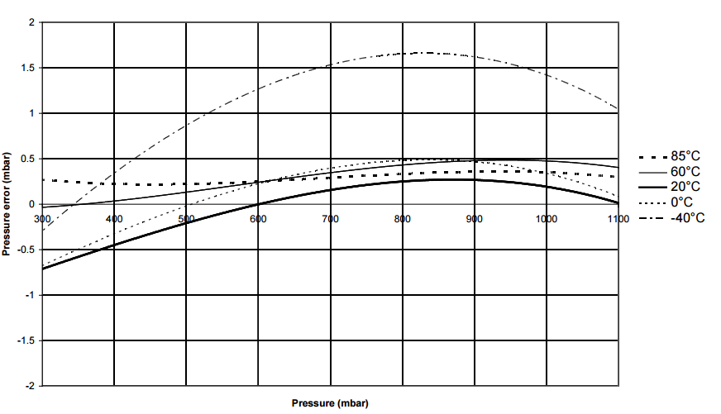
Figure1 Atmospheric pressure measurement accuracy at different temperatures
As shown in Figure 1, the accuracy of pressure measurements at different temperatures and under different pressure conditions are described.
1.4 Correlation effects of other parameters
Figure1 describes the effect of different temperatures on air pressure measurement. The following table describes the effect of different atmospheric pressures on the accuracy of air pressure measurement.
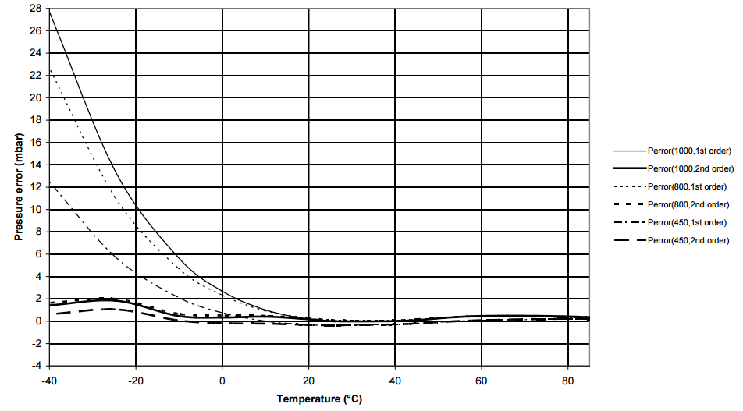
Figure2 Atmospheric pressure measurement error at different atmospheric pressures
1.5 System Frame Diagram
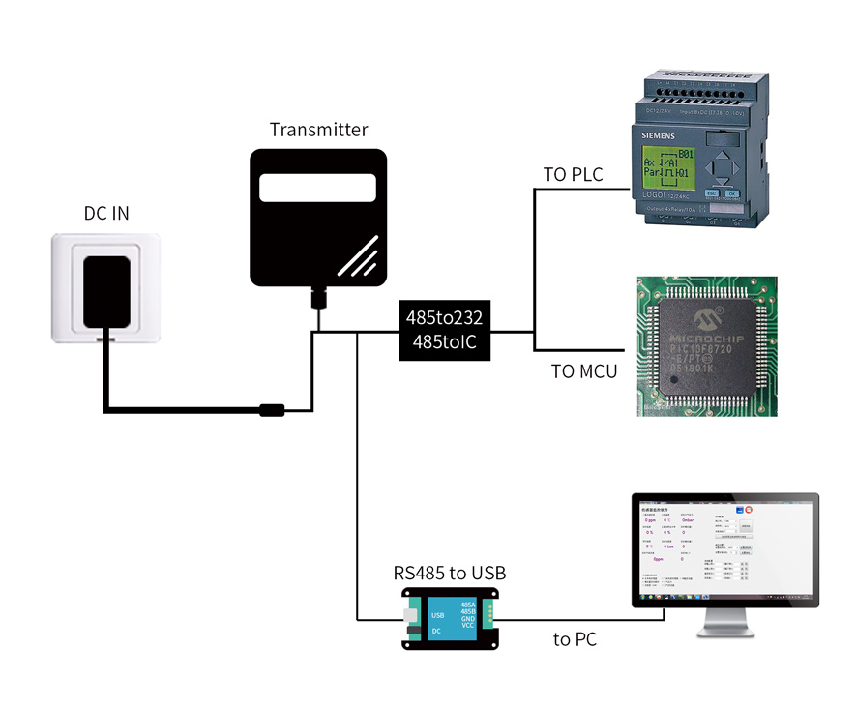
FIGURE 3 SINGLE-ENDED
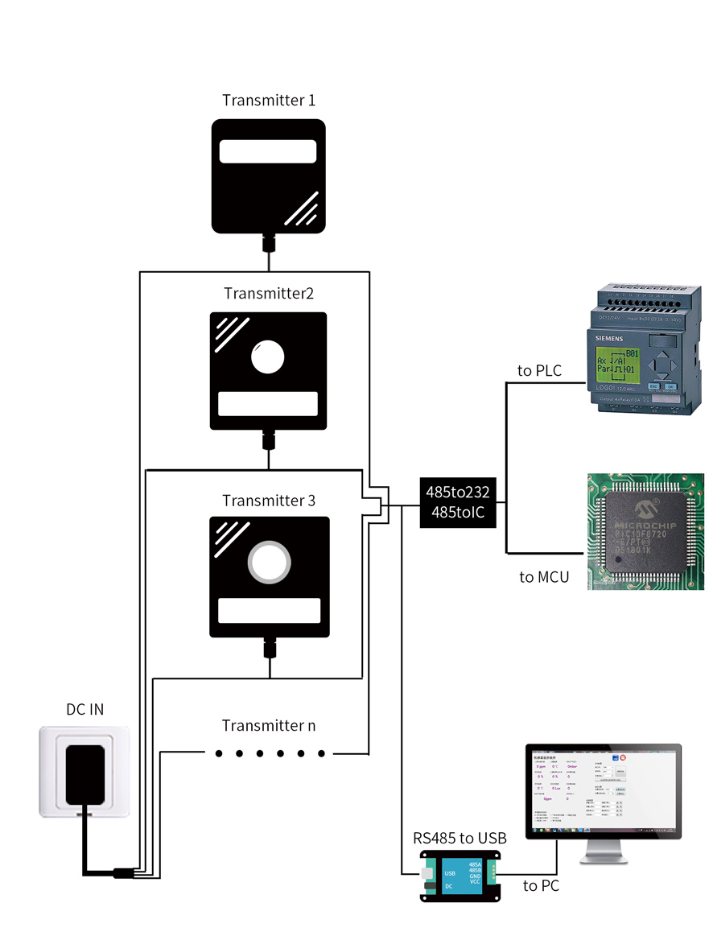
FIGURE 4 MUTIPLE-ENDED

Ⅱ Hardware Connections
2.1 CHECKING BEFORE INSTALLATION
Check the list of devices before installation:
TABLE 2 List of Devices
Name | Number
THE SENSOR DEVICE | 1
12V POWER ADAPTER（Optional） | 1
WARRANTY CARD / CERTIFICATE | 1
THE USB TO 485 DEVICE（Optional） | 1
2.2 Interface Description
Wide voltage power input can be 12-24V. When connecting the 485 signal cable, note that the A/B lines cannot be reversed. The addresses of multiple devices on the bus must not conflict.
2.2.1 Economic version barometer wiring instructions
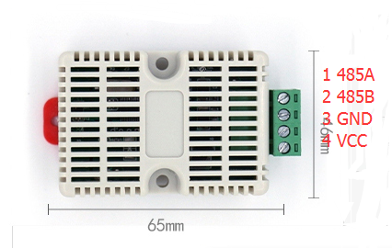
TABLE 3 Wiring Sequence
 | Line Color |  | Description
Power | VCC |  | Power supply Positive ( 12-24V DC )
Power | GND |  | Power supply Negative
Communication | 485-A |  | 485-A
Communication | 485-B |  | 485-B
Wiring method: After loosening the screw, insert the wire into the crimping hole from the terminal, and then tighten the screw to lock the wiring material.
2.2.2 Wall cabinet barometer wiring instructions
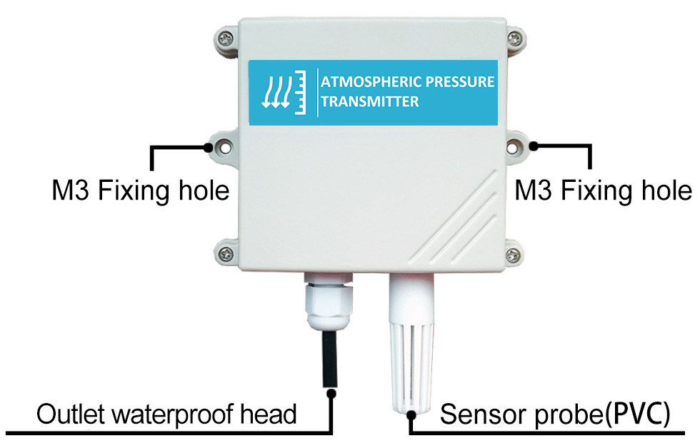
TABLE 4 Wiring Sequence
 | Line Color |  | Description
Power | Brown |  | Power supply Positive ( 12-24V DC )
Power | Black |  | Power supply Negative
Communication | Yellow ( Gray ) |  | 485-A
Communication | Blue |  | 485-B
Precautions: Please take care not to take the wrong line sequence, the wrong wiring will cause the equipment to burn.
The factory default is to provide 0.6 meters long wire, customers can extend the wire as needed or sequentially.
Note that there are no yellow lines in the wire sequences that may be provided in some factory batches, in which case the gray line is equivalent to replacing the yellow line.
2.3 Installation Description
The sensor needs to be installed in a sheltered and sheltered environment. The wall is perpendicular to the ground at 90 degrees, keeping the sensor vent directly below to prevent water ingress.
The prince shell is wall mounted. The mounting holes are located in the middle of the two sides of the device. The installation aperture is less than 4mm, and the hole distance is 105mm. You can use a 3mm self-tapping screw to install.
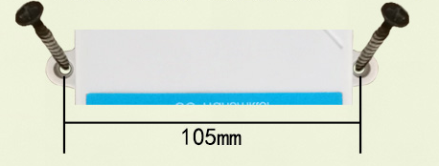
FIGURE 5 HOW FIXTURES

Ⅲ Configuration Tool Installation and use
We provide CONFIGURATION TOOL , which can be easily used to test our sensor device.
3.1 Sensor Access Computer
Transmitter can be connected to PC with the RS485 to USB adapter. You can check the COM port number through Device Manager (right click My Computer).
3.2 HOW TO USE CONFIGURATION TOOL
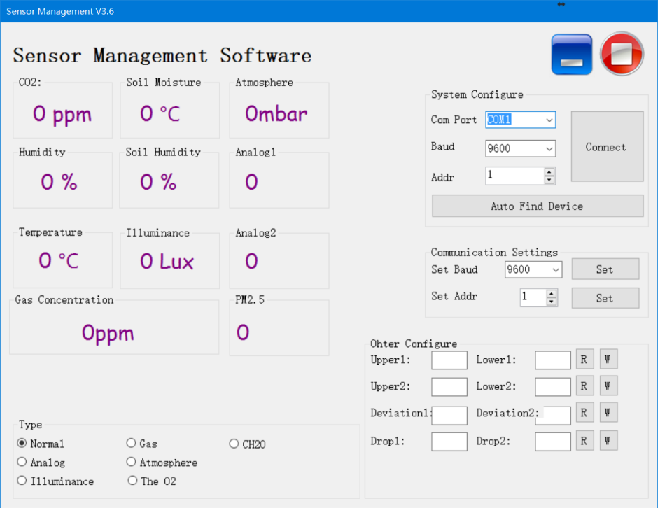
Please note that this software can only test one device at the same time. After connecting the physical device, click the CONNECT button to read the information. In the UNCONNET state, you can modify BAUD and ADDR in COMMUNICATION SETTINGS.
Under the software, different check boxes can be selected according to different situations. For example, you can choose the GAS option to test the RS485 OXYGEN SENSOR , you can choose the NORMAL option to test the RS485 TEMPERATURE AND HUMIDITY SENSOR .

Ⅳ Communication Protocol
4.1 Communication Basic Parameters
TABLE 5 Communication Basic Parameters
PARAMETERS | CONTENT
Protocol | Modbus RTU
Data bits | 8 bit
Parity bit | No
Stop bit | 1 bit
Error checking | CRC (redundant loop code)
Baud rate | 2400 bps/ 4800 bps/ 9600 bps can be set  factory defaults to 9600 bps
For more information about MODBUS RTU please visit the website"www.modbus.org ".
4.2 Register Address
TABLE 6 Register Address
Register Address | Plc Configuration Address | Content | Operation
0000H | 40001 | Humidity ( Unit 0.1%RH) | Read-Only
0001H | 40002 | Temperature ( Unit 0.1℃) | Read-Only
000AH | 4000B | Atmospheric pressure (high) | Read-Only
000BH | 4000C | Atmospheric pressure (low) | Read-Only
0100H | 40101 | Device Address (0-252) | R/W
0101H | 40102 | Baud Rate (2400/4800/9600) | R/W
4.3 Communication example
4.3.1 Read Device Address 0x01's Temperature And Humidity Value
Address Code | Function Code | Start Address | Data Length | CRC_L | CRC_H
0x01 | 0x03 | 0x00,0x01 | 0x00,0x01 | 0xD5 | 0xCA
TABLE 7 Inquiry Frame
TABLE 8 Answer Frame
Address Code | Function Code | Number Of Valid Bytes | Humidity Value | Temperature Value | CRC_L | CRC_H
0x01 | 0x03 | 0x04 | 0x02  0x92 | 0xFF  0x9B | 0x5A | 0x3D
Temperature：
FF9B H ( hexadecimal ) =-101=> Temperature =-10.1 ℃
Humidity：
292 H ( hexadecimal ) =658=> Humidity =65.8%RH
4.3.2 Read Device Address 0x01's Atmospheric pressure Value
Address Code | Function Code | Start Address | Data Length | CRC_L | CRC_H
0x01 | 0x03 | 0x00,0x0A | 0x00,0x02 | 0xE4 | 0x09
TABLE 9 Inquiry Frame
TABLE 10 Answer Frame
Address Code | Function Code | Number Of Valid Bytes | Atmospheric pressure_H | Atmospheric pressure_L | CRC_L | CRC_H
0x01 | 0x03 | 0x04 | 0x00  0x01 | 0x89  0x2a | 0x4D | 0xBC
4.3.3 Read Device Address 0x01's Temperature And Humidity, Atmospheric pressure Value
TABLE 11 Inquiry Frame
Address Code | Function Code | Start Address | Data Length | CRC_L | CRC_H
0x01 | 0x03 | 0x00  0x00 | 0x00  0x0C | 0x45 | 0xCF
TABLE 12 Answer Frame
Address Code | Function Code | Number Of Valid Bytes | Humidity Value | Temperature Value
0x01 | 0x03 | 0x18 | 0x02  0x64 | 0x01  0x1F
11 Useless Bytes |  | Useless Bytes | Pressure Data | Check Code
0x00 ... |  | 0x02 0xFF  0xFD 0x00  0x00 | 0x00 0x01  0x88 0xC5 | 0xF9  0xDD
Temperature：
011F H ( hexadecimal ) =287=> Temperature =28.7 ℃
Humidity：
0264 H ( hexadecimal ) =612=> Humidity =61.2%RH
Atmospheric pressure：
0188C5 H ( hexadecimal ) =100549=> Atmospheric pressure =1005.49mbar

